Lab 2

Introduction

Some of the Records from the File

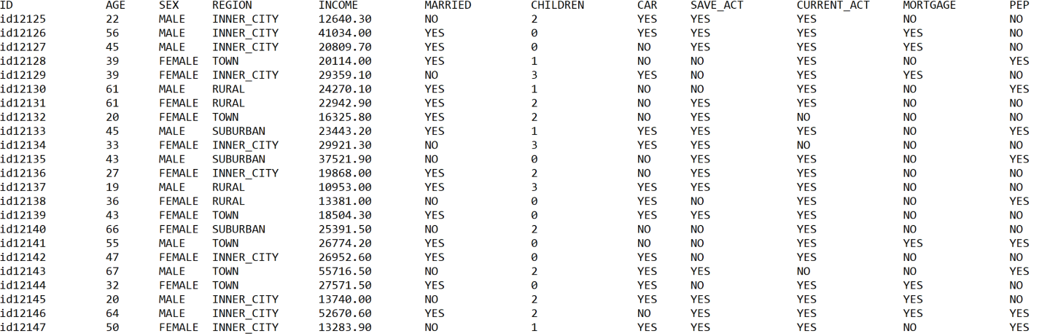

User Asks for Certain Number of Records

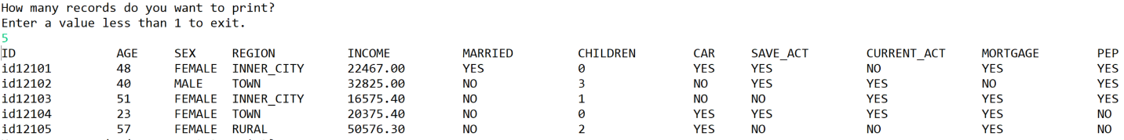

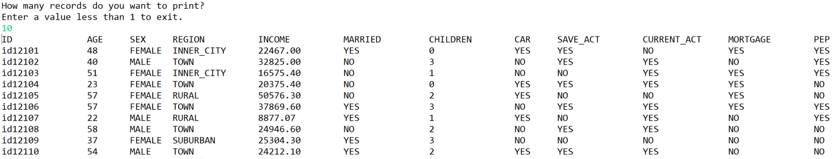

Exit Program and Number of Records in Program

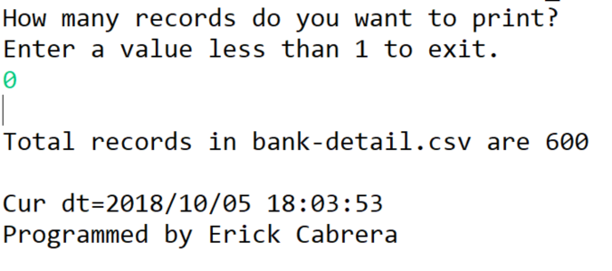

Error if File Not Found

